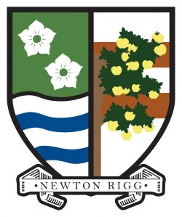
GRANT APPLICATION FORM- NEWTON RIGG SOCIETY
This form is to enable students studying or applying to study at Newton Rigg Training.
To apply for a grant from the Newton Rigg Society to assist you with your studies please complete the form below.
Full name
Address
Telephone No
E mail
Course attending or applied for
Amount applied for
Purposes of the grant
Date when grant required

In a few words please explain why receiving a grant will make a difference to your studies.

Please return your application to:
John Studholme john@studholmes.com

