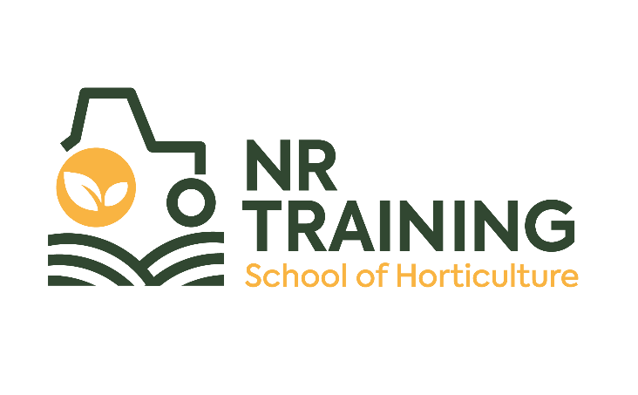
Hourly-Paid Tutor

Context
Newton Rigg Limited (NRL) was established in August 2020 to revive and restore land-based education and enterprise in Cumbria, and beyond, over a ten-year period. During the last two years NRL has fought to re-establish a centre for land-based education in Cumbria and is now poised, as a new charity, to push forward with its ambitious plans to operate the Cumbria Rural Business and Skills Centre at Newton Rigg as a specialist rural facility to lead positive developments in rural industries and communities and address the economic needs of the sector, alongside supporting the health and well-being of its people.
Our charitable object is to ‘advance the education of the public in rural and land-based subjects (including but not limited to, agriculture, countryside management, equine studies, land-based engineering, veterinary nursing and horticulture) by providing facilities, educational programmes and careers advice and guidance to students of all ages’.
Our Education and Training Development Strategy 2022-27 identifies our key services as:
- Full cost land-based education courses and programmes
- Adult land-based vocational courses and skills’ training AEB subcontract with Cumbria County Council
- A Community Digital Hub to support e-learning and blended learning pedagogy
- A Rural Business School to conduct applied research, consultancy and knowledge transfer with direct on farm/enterprise link to the farmers of Cumbria and beyond
- A Rural Apprenticeship Unit delivering outstanding apprenticeship provision in land-based engineering, forestry, horticulture and countryside management within 5 years
- Health and well-being wrap around support
- Schools’ provision for 14-18: careers, advice and guidance activities and pre-apprenticeship initiatives, such as ‘Young Engineers’.
- Programmes and facilities to support local and national initiatives such as ‘Skills Support for Unemployed’, ‘Multiply, ‘Inspiring Eden’ and Local Skills Improvement Plan for Cumbria.
In time, we will extend our services to include 16-18 ESFA funded education programmes, including T levels in land-based subjects.
The School of Horticulture was established in Sept 2021 and has successfully delivered horticultural training from its base at Lowther Castle and gardens. In January 2023 we re-Appleby Heritage Centre to offer engineering and joinery qualifications.
We are now seeking to expand our delivery team to accommodate changes to our delivery model and audience and require hourly paid tutors in the following subject areas:
- General engineering
- Welding
- Land-based engineering
- Joinery

Hourly-Paid Tutor

Job Description

Outline
Responsible to: Curriculum Manager
Responsible for: Adult Education for programmes on behalf of NR Training
Based at: NR Training, Appleby Heritage Centre or Newton Rigg Estates

Brief
As one of our education team, you will be responsible for tutoring on our adult education programmes.
Education
- Plan, prepare and deliver adult education sessions in accordance with a specific scheme of work
- Support and encourage students to learn and achieve the programme requirements using tutorial sessions as required
- Support the recruitment of students
- Monitor attendance and achievement, alerting the Curriculum Manager if required
- Assess all work and record progress
- Ensure the working environment is tidy at the end of the session

Health and safety
- Ensure that all activities are undertaken with due regard to health and safety and ensure compliance with our own policies and H&S legislation
- In collaboration with the rest of the team ensure that the NR Training is always a safe, clean, friendly, and welcoming place for all people working and visiting the site

Other
- Promote NR Training and partner organisations whenever possible
- Abide by all our company’s policies
- Undertake other duties as requested by your line manager and in line with the post
Hourly-Paid Tutor

Person Specification

Experience
- Experience of working within a practical workshop setting in engineering, joinery, land-based engineering or welding | Essential
- Experience of teaching or supporting adults | Desirable
- Experience of working alongside volunteers | Desirable

Knowledge and Understanding
- Knowledge of practical workshop skills | Essential
- Knowledge of safeguarding regulations and best practice | Desirable

Skills and Qualifications
- Teaching qualification or equivalent or willing to work towards  - Subject specialist qualification to Level 3 or equivalent experience | Essential  Essential
- Creative and innovative to meet the educational needs of all | Essential
- Excellent verbal and written communication skills  - Level 2 or equivalent in literacy (or willing to work towards)  - Level 2 or equivalent in numeracy (or willing to work towards) | Essential  Essential  Essential

Personal Qualities
- A flexible ‘can do’ approach | Essential
- Willingness to work flexibility when needed, working around the weather and in response to the needs of the company | Essential
- A real passion to help promote horticulture for everyone | Essential
- Personable, energetic and engaging | Essential
- Has a genuine interest in horticultural issues  - Driving licence with D1 (for small mini-bus) | Essential  Desirable
Hourly-Paid Tutor

Terms and Conditions
Salary: | £22 per hour.
Hours: | As agreed by line manager
Holidays: | 20 working days per annum in addition to normal public holidays (pro rata for part time hours).
Pensions: | 5% employer contribution
Notice Period: | One month following satisfactory completion of 3-month probationary period.
Place of Work: | The post will be based at NR Training, Appleby Heritage Centre or Newton Rigg Estate.
Travel: | In exceptional circumstances the use of a personal vehicle may be necessary for business use for which a mileage rate of 45p per mile will be paid for the first 10,000 miles and 25 pence per mile thereafter subject to reviews of our travel policy.
Training: | NR Training is fully committed to personal development and training. This will be discussed and agreed annually.
Closing date: | No closing date
Interview dates: | To be confirmed with candidates
Pre-interview visit: | By appointment
Starting Date: | TBC

To apply please send your completed application form to support@nrtraining.co.uk

