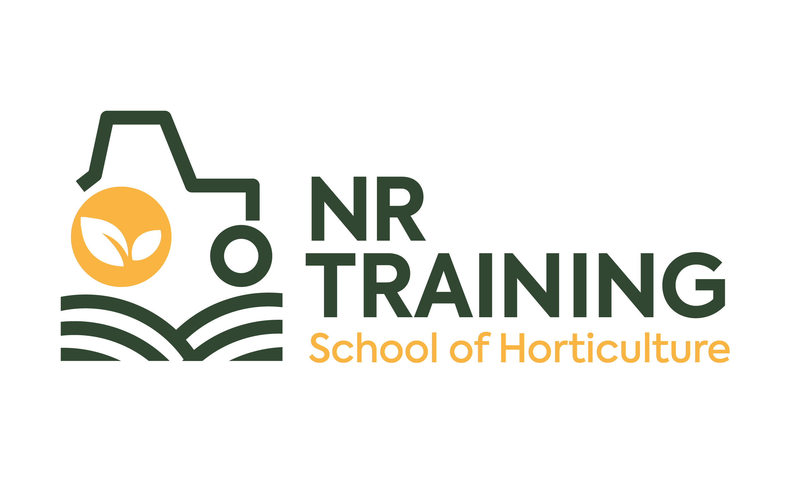 |  | NR Training School of Horticulture  The Old Shop  Lowther Castle and Gardens  Lowther, Penrith  Cumbria CA10 2HH  Dear Scholarship Applicant,  - Do you grow plants at home or help out on an allotment?  - Do you like working outdoors and have green fingers?  - If so, a career in horticulture might just be what you need?  A horticulture career is an exciting path to follow with dozens of roles in this important sector. Our sector supports food security, the environment, wellbeing, landscapes and tourism and is a vital part of the UK economy. There is a massive green skills gap, with 70% of employers saying they can’t find skilled workers.  To get you started with a new career our Scholarship Programme includes:  - Year 1 funding to complete our Certificate in Horticulture worth £950 (1 day/week for 26 weeks)  - Year 2 funding to complete our Diploma in Horticulture worth £950 (1 day/week for 26 weeks)  - Support to find a work placement or job with a local horticultural employer  - Support to apply for additional funding for transport and course resources  This scholarship is open to anyone aged 18-25 who lives in Cumbria and is passionate about horticulture.  Our horticultural courses are based at Lowther Castle and Gardens which is home to an amazing range of gardens to learn in.  If you are interested in applying, please complete the form below and email to jane@newtonriggtraining.co.uk alongside your personal statement. Our scholarship team will review your application- we only have 2 places available so get your application in now!  We look forward to hearing from you soon!  Application Form for Scholarship Programme  Name  Home address  DOB  Email  Phone  Personal Statement to be emailed separately.  In no more than 500 words please let us know about your interest in horticulture and why you feel you should be awarded this scholarship.  Please email this form and your accompanying personal statement to jane@newtonriggtraining.co.uk.  We will only use your personal information as set out in our privacy policy: available HERE.  We will only give your personal information to third parties where the law either requires or allows us to do so.

